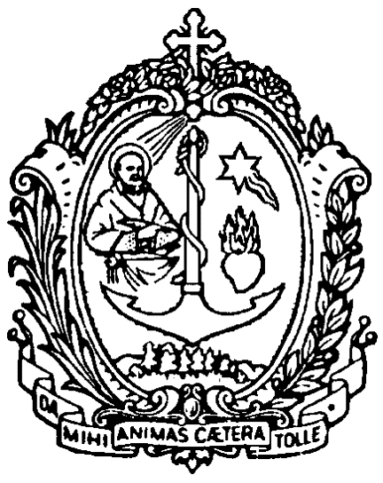
DIREZIONE GENERALE OPERE DON BOSCO
Via della Pisana 1111 - 00163 Roma

The Rcctor Major
Prot. 09/0623
Rome, 24 June 2009
Birth of Saint John the Baptist

To the Salesian Confreres
of the Congregation

Subject: “Remembering Don Rua”

My dear Confreres,

We are celebrating this Jubilee Year of 2009 in which we are commemorating the 150th anniversary of the founding of the Congregation. We thank God for the gifts of grace which this year brings us and for the fruits which it is bringing to maturity in ourselves, in our communities, in the young, in lay people and in families. One of these gifts is certainly the journey which the casket containing Don Bosco’s relic is making, having begun its pilgrimage in the Central Italy Province, and visited the UPS Vice Province and the Generalate of the FMA. In the next few days it will come to spend some time in our Generalate and then it will leave for Chile and the other countries of Latin America.
The climax of this jubilee year will be 18 December. On that day in a solemn ceremony held especially at local level, we shall renew our religious profession, re-affirming the gift of ourselves to God for the young. We want this act to be an ecclesial and public moment. It is important therefore to involve the young, lay people and families, the Salesian Bishops, the various groups of the Salesian Family. I will be spending this moment with the General Council in Turin, in the Basilica of Mary Help of Christians, but I shall certainly feel myself close to each one of you, in profound communion of spirit and in the joy of belonging to the wonderful Family of Don Bosco.
The reason for this letter of mine is to make the official announcement to you that we shall be dedicating the year 2010 to a special commemoration of Blessed Michael Rua. It is in fact the centenary year of his death, which occurred on 6 April 1910. The year 2010, centred on the figure of the first Successor of Don Bosco, from some points of view will be a continuation of this present jubilee year; it will help us to bring to fuller maturity our consecrated Salesian vocation. It seems to me important that we are conscious of the historical situation, that from the death of Don Bosco until our own days, the Congregation has had a great and significant development, taking steps forward, having second thoughts, making fresh starts, reflecting deeply. The identity of the Congregation can be understood better, in fact, through its history, knowing the forms and expressions it has assumed at different times and in different places.
“Remembering Don Rua”, we shall spend this year 2010 on a spiritual and pastoral journey. It will begin on 31 January, the solemnity of Don Bosco, the day on which each year we recall the death of the Saint: it was on that 31 January in 1888 that Don Rua took the tiller, to continue the journey on which the Founder had embarked. The year of commemoration will conclude on 31 January 2011. At Congregational level, among other things, there will be two meetings for historical reflection: between 28 October and 1 November 2009, in Turin, the Vth International Congress on Salesian History with the theme “Don Rua, the first Successor of Don Bosco” will be taking place; and later, between 29 October and 1 November 2010 at the “Salesianum” in Rome there will be an International Congress of the Salesian Congregation on the topic “Don Michael Rua in history.”
I mention now some focal points, to be borne in mind for your spiritual and pastoral planning for the coming year, at personal, community and Province level. They will be further and more amply developed in the circular letter in which I intend to illustrate at greater depth the figure of Blessed Michael Rua. It will be offered to all the confreres in the month of September 2009 and will be published in the next issue of the Acts of the General Council.
First of all, following the example of Don Rua, the faithful disciple of Jesus in the footsteps of Don Bosco, each confrere is being called to re-discover the ways in which to preserve fidelity to the vocation of consecration. Our vocation is a precious gift; however, it is “like a treasure in earthenware vessels.” The greatness of the gift received is often put at risk by the fragility of our response. I believe that placing ourselves in the presence of the life of this great witness to fidelity we need to ask ourselves: «Am I happy with God?»; and even more importantly: «Is God happy with me?». In fact, embracing Salesian consecrated life we set ourselves to follow the Lord Jesus and we become genuine disciples of His and zealous apostles; all this demands from us a convinced fidelity to our vocation. Let us therefore draw deeply from the wells of the life of the disciple and of the apostle, from the fountains of fidelity to our vocation: Sacred Scripture, through “lectio divina” and the Eucharist.
We can also underline one particular feature of our Salesian consecrated life. It is present in its two forms: ministerial and lay; in this year of the priesthood we can re-discover in particular the gift of the priesthood in the community and in the educative pastoral community.
When Don Rua was sent to Mirabello to found a new house, he summed up the advice received from Don Bosco in a single phrase: “In Mirabello I shall try to be Don Bosco”. How important it is that each one of us adopt the same attitude! In fact, this is also the project of life which we find expressed in our Constitutions: to be Don Bosco today, wherever we find ourselves living and working. Becoming Don Bosco, day after day, is precisely what the Constitutions set before us in practical terms. We know that after the approval of the Constitutions on 3 April 1874, on account of his exemplary way of life, Don Rua was called “the living rule”; he used to say: “Nothing can be considered small once it is in the Rule.”
Here then, dear Confreres, a second point to give attention to. Moved by the special witness given by the first successor of Don Bosco, I invite you, during this year, especially on the occasion of the Retreat, to re-discover the importance and the spirit of our Salesian Constitutions and to look again at your personal Plan of Life. Encouraged by the example of Don Rua and following the guidelines of the GC26, we want to commit ourselves to the study and the practice of our Constitutions, with particular reference to Chapter four: that which deals with our mission and is entitled “sent to the young.”

In the third place, we recall how Don Rua, moved by the passion of the Da mihi animas, gave a great impetus to the Salesian mission. It was the vitality of the mission that led him to initiate new forms of the apostolate, to raise up and to cultivate vocations to Salesian consecrated life, to launch out into other parts of the world. The mission called him to respond to the needs of the young and to find pastoral ways suited to reaching them with the proclamation of the gospel. Don Rua’s apostolic zeal, therefore, demands that we too during this year express in practical terms the commitment to evangelising the young. The second key issue in the GC26 requires it from us; the 2010 Strenna sets is before us as it invites us to let ourselves be caught up in the commitment to evangelisation as the Salesian Family of which Don Rua was a convinced promoter. The GC26 invites us to bring the gospel to the young, to be engaged, as evangelised and evangelising communities, in giving the central place to presenting Jesus Christ, in developing in a effective manner the link between evangelisation and education, bearing in mind the different contexts, and involving the families. Let us be inspired by this theme of the Chapter to begin to rethink our pastoral work.
May the Spirit of Christ inspire us on our journey of pastoral renewal and may Mary Help of Christians sustain us in our apostolic commitment. May Don Bosco, as ever, be our model and our guide.

Yours in the Lord,

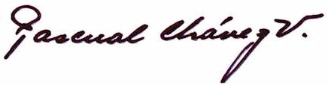
Fr Pascual Chávez Villanueva
Rector Major

